Weekly sponsor communication

|  |  |
| --- | --- |
| to: | Victor Nunez, Aesculap |
| from: | Brian Loughran |
| Editor:team name and Number: | cassie ChristmanAesculap 1 |
| dates covered in this communication: | october 18, 2016 to october 24, 2016 |
| Week Number: | 8 of 15 |
|  |  |

**Overview**

This week was a week of sorting through all the good feedback we received from the midterm presentation, and using that information to generate ideas that could get us closer to a final product. Some of the feedback that we found important was the need for ratchet integration and paddle quick connect features, as well as improving our FEA model.

**Accomplishments**

1. Cassie and Alexis did some research on the paddle quick connect system. After our final presentation last semester, it was recommended that we look into a bayonet connector as an option for the paddle quick connect system, but because of the complicated geometry on both the paddle and handle, we decided there were less expensive options. Cassie was looking at ball plungers, which is a spring and ball system for quickly locking and unlocking our paddle design. Alexis was looking into spring clips, which function similarly to ball plungers, but do not require a spring system. We plan on choosing a final design next week. If you have any insight on which would be better, that could be beneficial, just to give the team some direction.
2. Christian and Brian did some research on ratchet design. We are thinking of going with the socket wrench idea that we presented at the midterm because of the ease of use and familiarity associated with the design, and if that does not work, there are simpler options for a ratchet system. Some research was done looking into the design on these ratchet systems. We also looked at some previously filed and expired patents to get an idea of what kind of dimensioning would go into designing our own ratchet system. Shown below is an example of a ratchet system that we were looking into (Figure 1):

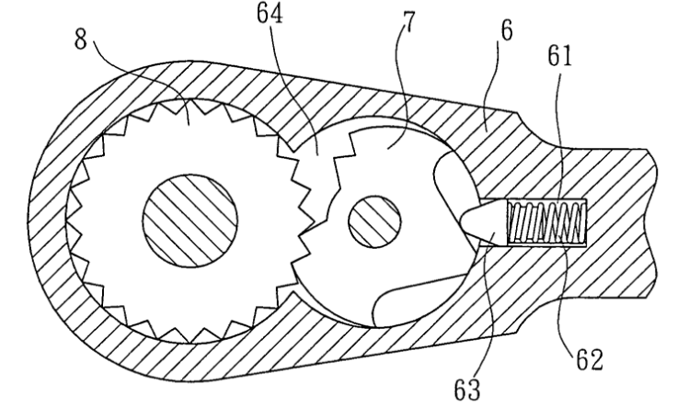

Figure 1 – Schematic of potential ratchet system design

1. We also had a presentation in class on standards. Much of the research was conducted last semester and recompiled to meet the presentation format, but it was good to look at all the standards we are trying to meet at this point in the design process. Some of the standards we were looking at include the FDA, ASME, and ISO standards, which covered biocompatibility, mechanical integrity, sterilization, surgical design, corrosion, and more. These standards will continue to be incorporated in our tool’s design.

**Next Steps**

1. We want to make a definite decision between the spring clip design and the ball plunger by the end of the week.
2. We want to begin to put dimensions on a potential ratchet system design. This will require a stress analysis of the mechanism.
3. Christian is planning a call for next week with Chris Good to talk about the FEA model.

**Questions**

1. We were unsure about being able to sterilize the ball plunger, spring clip, and ratchet systems. How can we know if autoclaving will be effective in sterilizing components? Are there specific design constraints in making a sterilizeable medical device?
2. Do you have any preference between the ball plunger mechanism or the spring clip mechanism?